**1.List any four applications of DBMS and explain**

**Database Management System (DBMS)** is a software that enables efficient storage, retrieval, and management of data. Here are four common applications of DBMS along with their explanations:

**1. Banking Systems**

**Application**: DBMS is crucial in managing customer data, account details, and transaction records in banking systems.  
**Explanation**:

* It facilitates the secure storage of sensitive customer information.
* Supports transactions like deposits, withdrawals, and fund transfers while ensuring data consistency through ACID (Atomicity, Consistency, Isolation, Durability) properties.
* Enables real-time access to account balances and transaction histories.
* Provides backup and recovery mechanisms for disaster management.

**2. E-commerce Platforms**

**Application**: E-commerce websites use DBMS to manage product inventories, customer details, orders, and payment information.  
**Explanation**:

* It organizes large volumes of product data, such as descriptions, prices, and stock availability.
* Manages customer profiles, shopping carts, and purchase histories.
* Ensures secure storage and processing of payment information.
* Facilitates data analysis for marketing strategies, such as personalized product recommendations.

**3. Healthcare Systems**

**Application**: DBMS is widely used in hospitals and clinics for patient management, medical records, and billing.  
**Explanation**:

* Maintains electronic health records (EHRs) of patients, including medical history, lab reports, and prescriptions.
* Provides quick access to patient information for doctors and medical staff.
* Integrates with diagnostic tools and medical equipment to store and analyze data.
* Supports billing, insurance claims, and reporting.

**4. Educational Institutions**

**Application**: Universities and schools use DBMS for managing student information, course details, and academic records.  
**Explanation**:

* Stores data on student enrollment, grades, attendance, and fees.
* Manages faculty records, schedules, and course materials.
* Provides tools for generating reports like transcripts and attendance summaries.
* Facilitates online learning systems and portals.

**2. State four advantages of DBMS over file processing system**.

**1. Data Redundancy and Consistency**

**Advantage**: A DBMS minimizes data redundancy (duplicate data) and ensures data consistency across the system.

* In file processing systems, the same data may be stored in multiple files, leading to redundancy and inconsistencies when data is updated in one location but not in others.
* In DBMS, a centralized database ensures that any update is reflected throughout the system, maintaining consistency.

**2. Improved Data Security**

**Advantage**: DBMS provides robust mechanisms for data access control and security.

* In file processing systems, controlling access to sensitive information is challenging, often resulting in unauthorized access.
* DBMS offers authentication, authorization, and encryption features, ensuring that only authorized users can access or modify the data.

**3. Data Integrity**

**Advantage**: DBMS enforces data integrity constraints to ensure data accuracy and reliability.

* File processing systems lack mechanisms to enforce rules, such as unique identifiers or valid data formats, leading to potential data errors.
* DBMS allows defining constraints like primary keys, foreign keys, and value restrictions to maintain data integrity.

**4. Efficient Data Retrieval and Querying**

**Advantage**: A DBMS enables complex queries and faster data retrieval using structured query languages (e.g., SQL).

* File processing systems require manually writing code or scripts for data retrieval, which is time-consuming and less flexible.
* With DBMS, users can efficiently retrieve specific data through queries, even from large datasets, improving productivity.

**3.Distinguish any four points between network model and hierarchical model**.

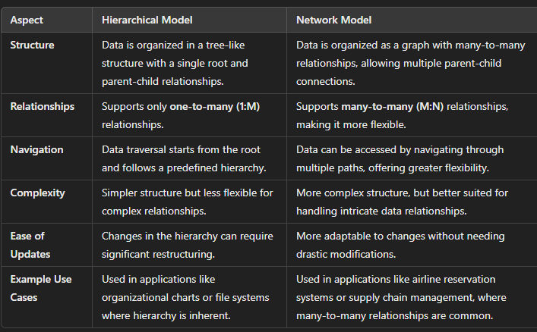

**6 . Explain the following: i) Instance, ii) Schema**

**Define Entity, Relationship and Attribute with an example.**

Entity:

An entity may be any object, class, person or place. In the ER diagram, an entity can be represented as rectangles.

Consider an organization as an example- manager, product, employee, department etc. can be taken as an entity.

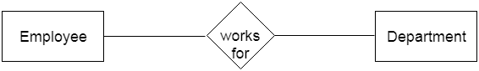

**a. Weak Entity**

An entity that depends on another entity called a weak entity. The weak entity doesn't contain any key attribute of its own. The weak entity is represented by a double rectangle.

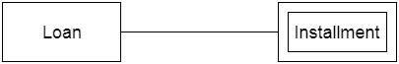

2. Attribute

The attribute is used to describe the property of an entity. Eclipse is used to represent an attribute.

**For example,** id, age, contact number, name, etc. can be attributes of a student.

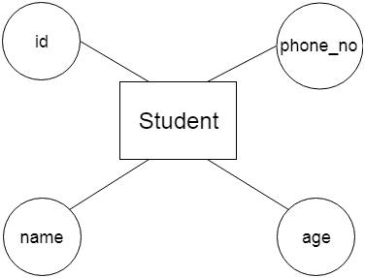

**a. Key Attribute**

The key attribute is used to represent the main characteristics of an entity. It represents a primary key. The key attribute is represented by an ellipse with the text underlined.

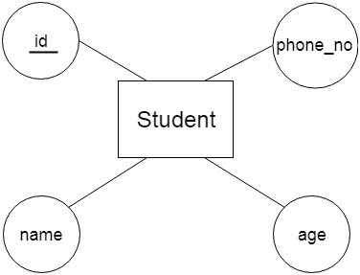

**b. Composite Attribute**

An attribute that composed of many other attributes is known as a composite attribute. The composite attribute is represented by an ellipse, and those ellipses are connected with an ellipse.

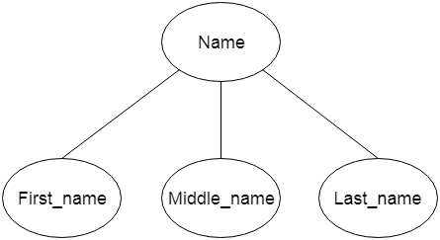

**c. Multivalued Attribute**

An attribute can have more than one value. These attributes are known as a multivalued attribute. The double oval is used to represent multivalued attribute.

**For example,** a student can have more than one phone number.

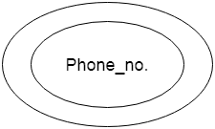

**d. Derived Attribute**

An attribute that can be derived from other attribute is known as a derived attribute. It can be represented by a dashed ellipse.

**For example,** A person's age changes over time and can be derived from another attribute like Date of birth.

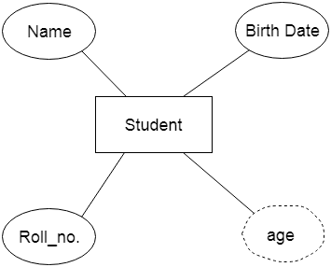

3. Relationship

A relationship is used to describe the relation between entities. Diamond or rhombus is used to represent the relationship.

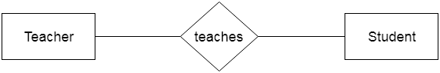

Types of relationship are as follows:

**a. One-to-One Relationship**

When only one instance of an entity is associated with the relationship, then it is known as one to one relationship.

**For example,** A female can marry to one male, and a male can marry to one female.

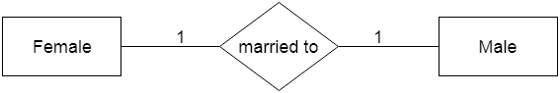

**b. One-to-many relationship**

When only one instance of the entity on the left, and more than one instance of an entity on the right associates with the relationship then this is known as a one-to-many relationship.

**For example,** Scientist can invent many inventions, but the invention is done by the only specific scientist.

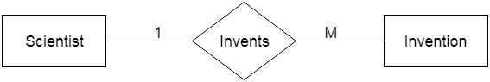

**c. Many-to-one relationship**

When more than one instance of the entity on the left, and only one instance of an entity on the right associates with the relationship then it is known as a many-to-one relationship.

**For example,** Student enrolls for only one course, but a course can have many students.

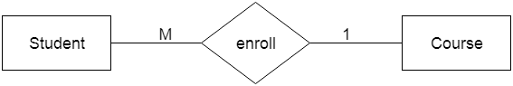

**d. Many-to-many relationship**

When more than one instance of the entity on the left, and more than one instance of an entity on the right associates with the relationship then it is known as a many-to-many relationship.

**For example,** Employee can assign by many projects and project can have many employees.

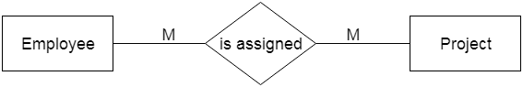

What is DBMS Schema?

Here the DBMS schema means designing the database. For example, if we take the example of the employee table. The employee table contains the following attributes. These attributes are EMP_ID, EMP_ADDRESS, EMP_NAME, EMP_CONTACT. These are the schema of the employee table.

Schema is further divided into three types. These three are as follows.

1. Logical schema.
2. View schema.
3. Physical schema.

The schema defines the logical view of the database. It provides some knowledge about the database and what data needs to go where.

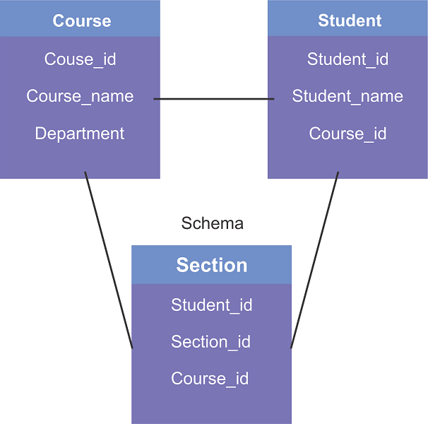

1. Physical schema:

In the physical schema, the database is designed at the physical level. At this level, the schema describes how the data block is stored and how the storage is managed.

2. Logical schema:

In the logical schema, the database is designed at a logical level. At this level, the programmer and data administrator perform their work. Also, at this level, a certain amount of data is stored in a structured way. But the internal implementation data are hidden in the physical layer for the security proposed.

3. View schema:

In view schema, the database is designed at the view level. This schema describes the user interaction with the database system.

Moreover, Data Definition Language (DDL) statements help to denote the schema of a database. The schema represents the name of the table, the name of attributes, and their types; constraints of the tables are related to the schema. Therefore, if users want to modify the schema, they can write DDL statements.

**What is DBMS Instance?**

In DBMS, the data is stored for a particular amount of time and is called an instance of the database. The database schema defines the attributes of the database in the particular DBMS. The value of the particular attribute at a particular moment in time is known as an instance of the DBMS.

For example, in the above example, we have taken the example of the attribute of the schema. In this example, each table contains two rows or two records. In the above schema of the table, the employee table has some instances because all the data stored by the table have some instances.

Differences between Database Schema and Instance

Both of these help in describing the data available in a database, but there is a fundamental difference between Schema and Instance in DBMS. Schema refers to the overall description of any given database. Instance basically refers to a collection of data and Information that the database stores at any particular moment.

The major differences between schema and instance are as follows:

|  |  |
| --- | --- |
| **Database Schema** | **Database Instance** |
| It is the definition of the database, or it is defined as the description of the database. | It is a snapshot of a database at a specific moment. |
| It rarely changes. | It changes frequently. |
| This corresponds to the variable declaration of a programming language. | The value of the variable in a program at a point in time corresponds to an instance of the database schema. |
| Defines the basic structure of the database, i.e., how the data will be stored in the database. | It is the set of Information stored at a particular time. |
| Schema is same for whole database. | Data in instances can be changed using addition, deletion, updation. |
| It does not change very frequently. | It changes very frequently |

**7.Define data model. List its types**.

 Data Model in Database Management System (DBMS)  is the concept of tools that are developed to summarize the description of the database. Data Models provide us with a transparent picture of data which helps us in creating an actual database. It shows us from the design of the data to its proper implementation of data.

**Types of Relational Models**

1. Conceptual Data Model
2. Representational Data Model
3. Physical Data Model

It is basically classified into 3 types:-

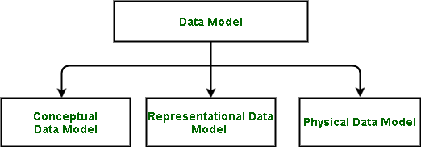

The conceptual data model describes the database at a very high level and is useful to understand the needs or requirements of the database. It is this model, that is used in the requirement-gathering process i.e. before the Database Designers start making a particular database. One such popular model is the [entity/relationship model (ER model)](https://www.geeksforgeeks.org/introduction-of-er-model/).

**2. Representational Data Model**

This type of data model is used to represent only the logical part of the database and does not represent the physical structure of the database. The representational data model allows us to focus primarily, on the design part of the database. A popular representational model is a [Relational model](https://www.geeksforgeeks.org/relational-model-in-dbms/). The relational Model consists of [Relational Algebra](https://www.geeksforgeeks.org/introduction-of-relational-algebra-in-dbms/) and [Relational Calculus](https://www.geeksforgeeks.org/tuple-relational-calculus-trc-in-dbms/).

**3. Physical Data Model**

 The physical Data Model is used to practically implement Relational Data Model. Ultimately, all data in a database is stored physically on a secondary storage device such as discs and tapes. This is stored in the form of files, records, and certain other data structures. It has all the information on the format in which the files are present and the structure of the databases, the presence of external data structures, and their relation to each other.

Define the following : i) Primary Key ii) Foreign Key

**i) Primary Key**

**Definition**: A **primary key** is a column or a combination of columns in a database table that uniquely identifies each row in that table.

* It ensures that no two rows in the table can have the same primary key value.
* The primary key value cannot be NULL.

**Key Features**:

1. Uniqueness: Each value must be unique across all rows.
2. Non-Null: It cannot have NULL values.
3. Immutable: Its value should not change frequently.

**Example**:  
In a **Student** table:

| **StudentID** | **Name** | **Age** |
| --- | --- | --- |
| 101 | Alice | 22 |
| 102 | Bob | 23 |

* **StudentID** can be the primary key because it uniquely identifies each student.

**ii) Foreign Key**

**Definition**: A **foreign key** is a column or a set of columns in a table that establishes a link between the data in two tables.

* It refers to the primary key in another table.
* It ensures referential integrity by ensuring that the value in the foreign key column matches a value in the referenced table's primary key or is NULL.

**Key Features**:

1. Referential Integrity: Maintains consistency between related tables.
2. Dependency: A foreign key in one table depends on the primary key of another table.
3. Multiple Foreign Keys: A table can have multiple foreign keys referencing different tables.

**Example**:

* **Student** table:  
  | StudentID | Name | Age |  
  |-----------|---------|-----|  
  | 101 | Alice | 22 |  
  | 102 | Bob | 23 |
* **Enrollment** table:  
  | EnrollmentID | StudentID | Course |  
  |--------------|-----------|--------|  
  | 1 | 101 | Math |  
  | 2 | 102 | Science|

**Describe Views and write a command to create view.**

**What is a View in DBMS?**

A **view** is a virtual table in a database that provides a specific representation of the data from one or more tables. Unlike actual tables, a view does not store data itself; instead, it derives data from the underlying base tables.

**Features of Views**

1. **Simplifies Data Access**: Views allow users to interact with a simplified or specific portion of the data.
2. **Enhances Security**: Sensitive columns or rows can be hidden by only exposing specific data through the view.
3. **Data Independence**: Underlying table structures can change without affecting the view or its users.
4. **Query Optimization**: Views can predefine complex queries, making it easier for users to retrieve the required data.

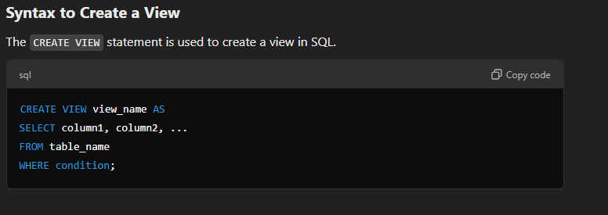

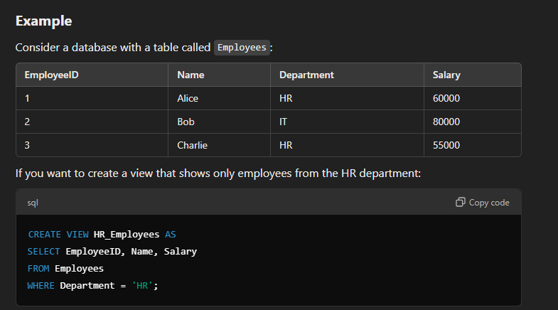

**List out the Problems related to decompositions?**

**1. Loss of Information**

**Problem**: Decomposition can lead to loss of data if it is not done properly, especially when it involves breaking down relations in a way that the original information is not fully retrievable.

**Example**:  
If you decompose a relation into smaller relations without preserving certain dependencies (like functional dependencies), some information may be lost when joining the decomposed relations back.

**2. Increased Complexity in Queries**

**Problem**: Decomposing a large relation into many smaller ones can make querying more complex. To retrieve a piece of information, you might need to perform multiple joins between the decomposed relations, which can increase query complexity and processing time.

**Example**:  
Instead of querying a single relation for information, you might need to perform multiple joins across several decomposed relations to gather the data, leading to inefficiency.

**3. Dependency Preservation**

**Problem**: It can be challenging to preserve all the functional dependencies after decomposition. If the decomposition does not preserve dependencies, some important constraints may be lost, leading to data anomalies (like update anomalies, insert anomalies).

**Example**:  
If you decompose a relation and lose a functional dependency, it could cause issues where the data is no longer consistent with the original constraints, making it difficult to maintain data integrity.

**4. Redundancy in Decomposed Relations**

**Problem**: After decomposition, some relations may still contain redundant data, which could lead to inefficiencies in storage and potential update anomalies.

**Example**:  
If two decomposed relations have overlapping attributes, the redundancy could lead to unnecessary repetition of data across relations, increasing storage needs.

**5. Difficulty in Reconstructing the Original Relation**

**Problem**: Sometimes, decompositions can make it difficult to reconstruct the original relation accurately. This issue arises when not all the necessary attributes are included in each decomposed relation, leading to problems when trying to reconstruct or join the relations back.

**Example**:  
If certain attributes are left out during decomposition, combining the relations back together can lead to incorrect or incomplete data.

**6. Loss of Data Integrity**

**Problem**: Decomposition can result in violations of **referential integrity** if foreign keys or relationships between tables are not properly maintained during the process. This can lead to inconsistencies in the database.

**Example**:  
If foreign key relationships are not correctly preserved after decomposition, it can lead to situations where related data in different tables becomes inconsistent or disconnected.

**Define the following terms: relation schema, relational database schema, domain, attribute.**

**1. Relation Schema**

**Definition**: A **relation schema** is a blueprint or structure that defines the organization of data within a relation (table). It specifies the name of the relation and the set of attributes (columns) that the relation consists of. Each attribute has a defined domain, and the relation schema represents the layout of the data, without holding any actual data itself.

**Components**:

* The **relation name**: The name of the table.
* The set of **attributes**: A list of attribute names and their domains.

**Example**:  
A relation schema for a **Student** table might look like:  
Student(StudentID, Name, Age, Major)

This specifies that the **Student** relation consists of the attributes StudentID, Name, Age, and Major.

**2. Relational Database Schema**

**Definition**: A **relational database schema** is a collection of relation schemas that define the structure of a relational database. It includes all the tables (relations), their attributes, and the relationships between them. The database schema also specifies constraints (like primary keys, foreign keys, and other integrity constraints) that ensure data consistency and integrity.

**Components**:

* A set of **relation schemas**.
* **Integrity constraints**: Rules like primary keys, foreign keys, and domain constraints.
* **Relationships** between the relations.

**Example**:  
A relational database schema for a school database might include:

* Student(StudentID, Name, Age, Major)
* Course(CourseID, CourseName, Credits)
* Enrollment(StudentID, CourseID) (relationship between students and courses).

This schema defines how the tables are structured and related in the database.

**3. Domain**

**Definition**: A **domain** is the set of all possible values that an attribute can take. It defines the range of values that are allowed for a specific attribute. Domains help ensure data integrity by restricting the values that can be inserted into a table's column.

**Example**:

* The domain of the Age attribute might be restricted to integer values between 0 and 150.
* The domain of the Major attribute could be restricted to a set of predefined strings, such as "Computer Science", "Mathematics", "Biology", etc.

**4. Attribute**

**Definition**: An **attribute** is a property or characteristic of an entity that is represented by a column in a relational table. Each attribute contains specific data about the entity it represents and has an associated domain.

**Example**:  
In a **Student** relation, possible attributes could be:

* StudentID (unique identifier for each student)
* Name (the student's name)
* Age (the student's age)
* Major (the student's academic specialization)

Each attribute has a specific data type, such as integer, string, or date, and belongs to a domain of allowable values.

**What is the difference between a candidate key and the primary key for a given relation? What is a superkey?**

**1. Candidate Key**

**Definition**: A **candidate key** is any attribute or a set of attributes that can uniquely identify a tuple (record) in a relation (table).

* A **relation** can have multiple candidate keys, each capable of uniquely identifying records.
* A candidate key is not necessarily the primary key but is a valid key for the table.

**Key Features**:

* Each candidate key uniquely identifies records in the table.
* There can be multiple candidate keys in a table.
* A candidate key must be minimal, meaning it cannot have any unnecessary attributes (it should be irreducible).

**Example**: In a **Student** table:

| **StudentID** | **Name** | **Email** |
| --- | --- | --- |
| 101 | Alice | alice@email.com |
| 102 | Bob | bob@email.com |

Here, both **StudentID** and **Email** can uniquely identify a student. Hence, both are candidate keys.

**2. Primary Key**

**Definition**: The **primary key** is a **candidate key** that is selected as the main unique identifier for a relation.

* A **primary key** is chosen from among the candidate keys to uniquely identify records in the table.
* The primary key is used to enforce **entity integrity**, ensuring no duplicate or NULL values for that column.

**Key Features**:

* There is **only one primary key** for a table.
* It cannot contain **NULL** values.
* It is the key selected from among the candidate keys for practical use (i.e., the one that is easiest or most efficient for referencing).

**Example**: For the **Student** table, if **StudentID** is chosen as the primary key, the table would look like:

| **StudentID** | **Name** | **Email** |
| --- | --- | --- |
| 101 | Alice | alice@email.com |
| 102 | Bob | bob@email.com |

In this case, **StudentID** is the primary key, even though **Email** is also a candidate key.

**3. Superkey**

**Definition**: A **superkey** is any set of attributes (columns) that can uniquely identify a tuple in a relation.

* A superkey may contain additional attributes that are not necessary to uniquely identify a tuple. A superkey is considered valid as long as it can uniquely identify each row in the table.
* Every **candidate key** is a superkey, but not every superkey is a candidate key.

**Key Features**:

* A superkey can have extra attributes that are not essential for uniqueness (i.e., it can be a superset of the candidate key).
* Superkeys include all the candidate keys, but they may include unnecessary attributes.

**Example**: In the **Student** table, if the **StudentID** is a candidate key, then any set of attributes that includes **StudentID** and any additional attributes (like **Name** or **Email**) would form a **superkey**.

| **Superkey** | **Explanation** |
| --- | --- |
| {StudentID} | This is the candidate key, and also a superkey. |
| {StudentID, Name} | This is a superkey because it still uniquely identifies each record, even though it's not minimal. |
| {StudentID, Email} | Another superkey that includes unnecessary attributes (Email) but still uniquely identifies a student. |

**Summary of Key Differences:**

| **Concept** | **Definition** | **Example** |
| --- | --- | --- |
| **Candidate Key** | A set of attributes that can uniquely identify records in a table. Multiple candidate keys may exist. | **StudentID**, **Email** |
| **Primary Key** | A candidate key chosen as the main unique identifier for the table. It cannot contain NULLs. | **StudentID** |
| **Superkey** | A set of attributes that can uniquely identify a record. It can include unnecessary attributes. | {StudentID, Name}, {StudentID, Email} |

**What is join operation in sql? Mention the different types of joins.**

**Join Operation in SQL**

A **JOIN** operation in SQL is used to combine rows from two or more tables based on a related column between them. The purpose of using joins is to retrieve data from multiple tables in a single query by linking related data from those tables.

**Types of Joins**

There are several types of joins in SQL, each with different behavior regarding how rows from the tables are combined:

**1. INNER JOIN**

**Definition**: The **INNER JOIN** returns only the rows that have matching values in both tables. If there is no match, the row is not included in the result.

**Syntax**:

sql

Copy code

SELECT columns

FROM table1

INNER JOIN table2

ON table1.column = table2.column;

**Example**: Consider two tables:

* **Students** (StudentID, Name)
* **Enrollments** (StudentID, CourseID)

Query:

sql

Copy code

SELECT Students.Name, Enrollments.CourseID

FROM Students

INNER JOIN Enrollments

ON Students.StudentID = Enrollments.StudentID;

This query will return only students who are enrolled in at least one course.

**2. LEFT JOIN (or LEFT OUTER JOIN)**

**Definition**: The **LEFT JOIN** returns all rows from the left table and the matched rows from the right table. If there is no match, NULL values are returned for columns from the right table.

**Syntax**:

sql

Copy code

SELECT columns

FROM table1

LEFT JOIN table2

ON table1.column = table2.column;

**Example**: Query:

sql

Copy code

SELECT Students.Name, Enrollments.CourseID

FROM Students

LEFT JOIN Enrollments

ON Students.StudentID = Enrollments.StudentID;

This query returns all students, including those who are not enrolled in any courses. For students with no enrollments, the CourseID will be NULL.

**3. RIGHT JOIN (or RIGHT OUTER JOIN)**

**Definition**: The **RIGHT JOIN** returns all rows from the right table and the matched rows from the left table. If there is no match, NULL values are returned for columns from the left table.

**Syntax**:

sql

Copy code

SELECT columns

FROM table1

RIGHT JOIN table2

ON table1.column = table2.column;

**Example**: Query:

sql

Copy code

SELECT Students.Name, Enrollments.CourseID

FROM Students

RIGHT JOIN Enrollments

ON Students.StudentID = Enrollments.StudentID;

This query will return all courses, even those that have no students enrolled. For courses with no students, the Name will be NULL.

**4. FULL JOIN (or FULL OUTER JOIN)**

**Definition**: The **FULL JOIN** returns all rows when there is a match in either the left or right table. It returns NULL for missing matches from each side.

**Syntax**:

sql

Copy code

SELECT columns

FROM table1

FULL JOIN table2

ON table1.column = table2.column;

**Example**: Query:

sql

Copy code

SELECT Students.Name, Enrollments.CourseID

FROM Students

FULL JOIN Enrollments

ON Students.StudentID = Enrollments.StudentID;

This query will return all students and all courses. If a student is not enrolled in a course, the CourseID will be NULL. If a course has no students, the Name will be NULL.

**5. CROSS JOIN**

**Definition**: The **CROSS JOIN** returns the Cartesian product of both tables. This means it will return all possible combinations of rows between the two tables. No condition is applied for matching rows.

**Syntax**:

sql

Copy code

SELECT columns

FROM table1

CROSS JOIN table2;

**Example**: Query:

sql

Copy code

SELECT Students.Name, Courses.CourseID

FROM Students

CROSS JOIN Courses;

If the **Students** table has 5 rows and the **Courses** table has 3 rows, the result will have 15 rows (5 * 3), with every student paired with every course.

**What is 2-phase locking protocol? Compare 2PL with Strict 2PL protocol.**

**2-Phase Locking Protocol (2PL)**

The **2-Phase Locking Protocol (2PL)** is a concurrency control mechanism used in database management systems to ensure transaction serializability, which prevents conflicts in a multi-user environment. The protocol ensures that transactions are executed in a manner that avoids anomalies such as lost updates, temporary inconsistency, and uncommitted data.

**trict 2-Phase Locking Protocol (Strict 2PL)**

**Strict 2PL** is a more restrictive version of the 2PL protocol. In this protocol, a transaction must hold all its locks until it is **committed or aborted**. This means that in strict 2PL:

* A transaction can **acquire** locks in the growing phase.
* A transaction **cannot release any locks** until it is ready to commit or abort (i.e., the shrinking phase begins after commit or abort).

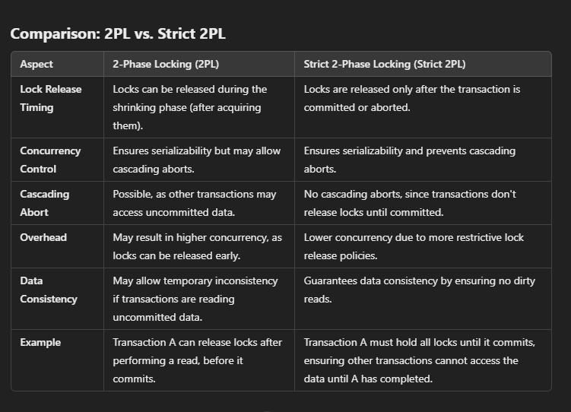

**What is need of lock in DBMS? Explain shared lock and exclusive lock with the help of example**

**Need for Lock in DBMS**

In a **Database Management System (DBMS)**, **locks** are used to control access to data in a multi-user environment. The need for locks arises from the following requirements:

1. **Concurrency Control**: Locks prevent multiple transactions from accessing and modifying the same data simultaneously, ensuring that the database remains consistent even when multiple users interact with it at the same time.
2. **Data Integrity**: Locks ensure that no conflicting operations (such as two transactions trying to update the same data item) occur concurrently. This helps to prevent anomalies like lost updates, temporary inconsistency, and uncommitted data from being read.
3. **Preventing Dirty Reads**: By locking the data, a transaction can ensure that other transactions cannot read data that has not yet been committed (dirty reads), which could lead to incorrect results or inconsistencies.
4. **Ensuring Serializability**: Locks are used to ensure that the sequence of operations performed by transactions preserves the integrity of the database, i.e., the schedule of transactions should be serializable.
5. **Isolation Level Management**: Locks help in achieving various isolation levels (like Read Committed, Repeatable Read, Serializable) by controlling the access of transactions to data, providing different degrees of isolation between transactions.

**Types of Locks: Shared Lock and Exclusive Lock**

**1. Shared Lock (S Lock)**

**Definition**: A **shared lock** allows multiple transactions to **read** a data item concurrently but **prevents** any transaction from **writing** to that data item. Essentially, multiple transactions can hold a shared lock on the same data item, but no transaction can modify the data until all shared locks are released.

**Behavior**:

* Multiple transactions can acquire a shared lock on the same data item simultaneously.
* Any transaction holding a shared lock can only **read** the data.
* No transaction can acquire an exclusive lock on the data while there is a shared lock.

**Example**: Suppose we have a table **Books** with a column StockQuantity:

| **BookID** | **Title** | **StockQuantity** |
| --- | --- | --- |
| 1 | Book A | 50 |
| 2 | Book B | 30 |

Transaction 1 (T1) wants to read the StockQuantity of **Book A**:

sql

Copy code

BEGIN TRANSACTION T1;

SELECT StockQuantity FROM Books WHERE BookID = 1; -- Reading the data

Transaction 1 acquires a **shared lock** on **Book A's** StockQuantity and can read the value.

At the same time, Transaction 2 (T2) can also read the same data:

sql

Copy code

BEGIN TRANSACTION T2;

SELECT StockQuantity FROM Books WHERE BookID = 1; -- Reading the same data

Transaction 2 also acquires a **shared lock** and can read the data concurrently with T1. However, neither transaction can modify the data until the locks are released.

**2. Exclusive Lock (X Lock)**

**Definition**: An **exclusive lock** allows a transaction to **read and modify** a data item, while preventing other transactions from **reading or writing** to that data item. It ensures that no other transaction can access the data in any way until the exclusive lock is released.

**Behavior**:

* Only one transaction can acquire an exclusive lock on a data item at a time.
* No other transaction can acquire any lock (shared or exclusive) on the data item while an exclusive lock is held.
* The transaction holding the exclusive lock can **read and write** the data.

**Example**: Suppose Transaction 3 (T3) wants to **update** the StockQuantity of **Book A**:

sql

Copy code

BEGIN TRANSACTION T3;

UPDATE Books SET StockQuantity = 45 WHERE BookID = 1; -- Updating the data

Transaction 3 will acquire an **exclusive lock** on **Book A's** StockQuantity, which allows it to modify the data.

While T3 holds the exclusive lock:

* **No other transaction** (such as T1 or T2) can acquire either a shared or exclusive lock on **Book A**.
* The data cannot be read or modified by other transactions until T3 releases the lock.

**What is a lock? Name the different types of lock**.

**What is a Lock in DBMS?**

A **lock** in a Database Management System (DBMS) is a mechanism used to control access to data items during concurrent transaction processing. Locks are applied to prevent conflicts and ensure the consistency and integrity of the data when multiple transactions are running concurrently.

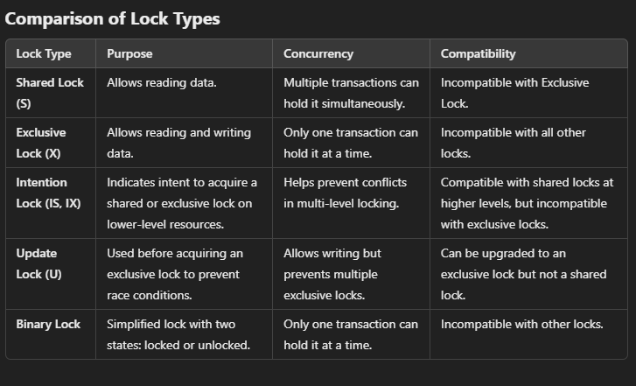

**Explain the concurrent control with times stamping.**

**Timestamp Ordering for Concurrency Control**

**Timestamp ordering** is a way to manage concurrent transactions in a database system by using timestamps (unique identifiers) to decide the order of operations. Each transaction gets a timestamp when it starts, and the system uses these timestamps to ensure that the database remains consistent.

**How Timestamp Ordering Works**

1. **Assigning Timestamps**:  
   Each transaction gets a unique **timestamp** when it starts, which determines its **order** relative to other transactions.
2. **Rules for Operations**:
   * **Read Operation**: A transaction can **read** a data item if no transaction that **wrote** to that item has a timestamp later than the transaction’s timestamp.
   * **Write Operation**: A transaction can **write** to a data item only if no transaction has **read** or **written** to that item with a later timestamp.
3. **Conflict Resolution**:
   * If two transactions have conflicting operations (like one reads and the other writes to the same data item), the transaction with the **older timestamp** is allowed to proceed, and the transaction with the **newer timestamp** is rolled back or aborted.

**Example:**

* **Transaction 1** (T1) starts with timestamp 10.
* **Transaction 2** (T2) starts with timestamp 20.

**If T1 reads a data item X:**

* T2 can **also read** X because there’s no conflict (both can read the same item at the same time).

**If T1 writes to X:**

* T2 cannot **write** to X because T1 already wrote to it, and T2 has a later timestamp. T2 will be **rolled back**.

**Benefits:**

* **Simple and Efficient**: The system uses timestamps to easily order transactions.
* **No Deadlocks**: Unlike other methods, timestamp ordering doesn’t require waiting, so there are no deadlocks.

**Drawbacks:**

* **Rollback**: If conflicts happen, transactions are rolled back, which can reduce efficiency.
* **Starvation**: Some transactions might keep getting rolled back if they are consistently conflicted with others.

In short, **timestamp ordering** ensures transactions are executed in the correct order based on their timestamps, preventing conflicts and maintaining data consistency.

Discuss the problems caused by redundancy and the purpose of normalization.

**Problems Caused by Redundancy in Databases**

**Redundancy** in databases refers to the repetition of data across multiple tables or records. While redundancy may sometimes be necessary for performance reasons, it can also lead to several serious issues, including:

1. **Data Anomalies**:
   * **Insertion Anomaly**: If redundant data is inserted incorrectly, it can lead to inconsistencies. For example, if a customer’s address is stored in multiple places, adding a new customer with their address in one table but forgetting to add it in another can cause inconsistency.
   * **Update Anomaly**: When data is repeated in multiple places, updating it in one location but not in others can lead to different versions of the same data, making the database unreliable. For instance, updating a customer’s phone number in one table but not in another causes inconsistency.
   * **Deletion Anomaly**: Deleting data from one table can unintentionally lead to the loss of important related data in other tables. For example, deleting a customer's record may accidentally remove all related orders if the information is redundantly stored.
2. **Increased Storage Requirements**: Redundant data means storing the same information multiple times, which wastes storage space and makes the database larger than necessary.
3. **Inefficiency in Query Processing**: Redundant data can slow down query performance, as the database engine has to handle larger datasets with repetitive information.
4. **Inconsistency**: When the same data exists in multiple places, there’s a risk that different versions of the data might become inconsistent over time, especially when updates or deletions are not properly managed.

**Purpose of Normalization**

**Normalization** is the process of organizing data in a relational database to eliminate redundancy and avoid the problems listed above. It involves dividing large, redundant tables into smaller, non-redundant tables and defining relationships between them.

The main purposes of normalization are:

1. **Eliminating Redundancy**: By organizing data into multiple related tables, normalization ensures that each piece of data is stored only once. This helps to avoid the problems caused by data anomalies.
2. **Improving Data Integrity**: Normalization ensures that data is consistent across the database. With fewer places to update or delete data, it’s easier to maintain accuracy.
3. **Optimizing Storage**: By reducing redundant data, normalization reduces the overall size of the database, saving storage space and improving performance.
4. **Facilitating Easier Updates**: When data is normalized, it’s easier to make updates. Since data appears in only one place, updates are simple and less likely to lead to inconsistencies.
5. **Enhancing Query Performance**: Normalization can improve query performance by organizing data into logical structures, making it easier for the database management system to handle queries efficiently.

**State and explain the causes of database failures.**

**causes of Database Failures**

1. **Hardware Failures**:
   * Hardware failures such as disk crashes, power outages, or network failures can lead to database unavailability, data corruption, or loss. For example, a sudden power failure can interrupt transactions, causing incomplete data writes or corruption.
2. **Software Failures**:
   * Bugs or errors in the database management system (DBMS) software or underlying operating systems can cause database crashes or corrupt data. Software bugs, memory leaks, or unhandled exceptions can disrupt database operations.
3. **Human Errors**:
   * Accidental actions by users or administrators, such as deleting data unintentionally or incorrect configuration of the DBMS, can cause data loss or inconsistencies. For example, a user might mistakenly delete critical records, affecting the database's integrity.
4. **Concurrency Problems**:
   * Issues such as deadlocks (when two transactions are waiting for each other), lost updates, or inconsistent reads can occur when multiple transactions are executed simultaneously without proper coordination, leading to data inconsistencies or errors.
5. **Transaction Failures**:
   * A transaction failure occurs when a transaction cannot be completed successfully due to errors in the application, timeouts, or violation of database constraints (e.g., trying to insert duplicate keys). This can leave the database in an inconsistent state.
6. **Security Breaches**:
   * Unauthorized access or attacks such as SQL injection can lead to data breaches, theft, or manipulation of sensitive information. Poor access control and weak authentication can allow attackers to compromise the database.

**List and explain various issues while transactions are running concurrently in DBMS.**

**Issues While Transactions Are Running Concurrently in DBMS**

1. **Lost Update**:
   * **Explanation**: This issue occurs when two transactions simultaneously read the same data and then update it independently. One transaction’s update may overwrite the other’s, causing data loss.
   * **Example**: Transaction A and Transaction B both read the balance of a bank account, and both update it by adding $100. Transaction B's update could overwrite A’s update, resulting in a loss of $100.
2. **Temporary Inconsistency (Dirty Read)**:
   * **Explanation**: A **dirty read** happens when one transaction reads data that has been modified by another transaction but not yet committed. If the second transaction is rolled back, the first transaction ends up reading incorrect data.
   * **Example**: Transaction A updates a record, but before committing, Transaction B reads that updated data. If Transaction A is rolled back, the data read by Transaction B becomes invalid.
3. **Uncommitted Data (Non-repeatable Read)**:
   * **Explanation**: This occurs when a transaction reads data and another transaction changes that data before the first transaction can complete. As a result, the first transaction may read different values during its execution, leading to inconsistencies.
   * **Example**: Transaction A reads the price of a product. Transaction B updates the price, and when Transaction A tries to read it again, it sees a different value, leading to inconsistency.
4. **Phantom Reads**:
   * **Explanation**: A **phantom read** happens when a transaction reads a set of rows that match a condition, but another transaction inserts, deletes, or updates rows that would change the result of the query. This results in the transaction seeing different data during its execution.
   * **Example**: Transaction A reads all records of employees with a salary over $50,000. Transaction B inserts a new employee with a salary over $50,000, which causes the next read by Transaction A to include the new employee, even though they were not there initially.

**Explain by taking some examples difference between the terms serial schedule and serializable schedule?**

Difference Between Serial Schedule and Serializable Schedule

1. Serial Schedule:
   * Explanation: A serial schedule is one in which transactions are executed sequentially, one after the other, with no overlapping. Each transaction starts only after the previous one has completed, ensuring no interleaving of operations.
   * Example:
     + Transaction 1: Read(A), Write(A)
     + Transaction 2: Read(B), Write(B)  
       In this case, Transaction 1 completes fully before Transaction 2 begins. This is a serial schedule.
2. Serializable Schedule:
   * Explanation: A serializable schedule is one where transactions are interleaved, but the final outcome is equivalent to a serial execution of the transactions. This means the result of a serializable schedule is the same as if the transactions had been executed serially (without any conflicts).
   * Example:
     + Transaction 1: Read(A), Write(A)
     + Transaction 2: Read(B), Write(B)
     + Interleaved schedule:
       - T1: Read(A), Write(A)
       - T2: Read(B), Write(B) In this interleaved schedule, even though T1 and T2 are executed concurrently, the outcome is still equivalent to a serial execution where T1 runs completely before T2 or vice versa. Thus, the schedule is serializable

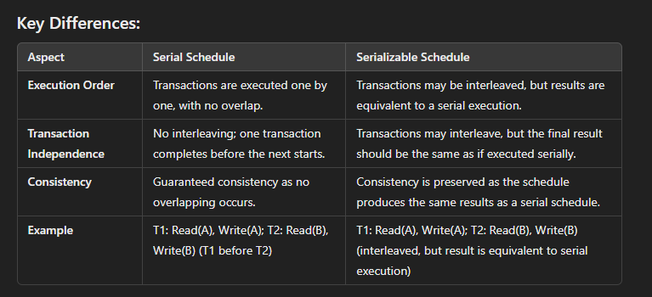

**Discuss Serializability in detail?**

**Demonstrate Conflict Serializability.**

if a non-serial schedule can be transformed into its corresponding serial schedule, it is said to be serializable. Simply said, a non-serial schedule is referred to as a serializable schedule if it yields the same results as a serial timetable.

Non-serial Schedule

A schedule where the transactions are overlapping or switching places. As they are used to carry out actual database operations, multiple transactions are running at once. It's possible that these transactions are focusing on the same data set. Therefore, it is crucial that non-serial schedules can be serialized in order for our database to be consistent both before and after the transactions are executed.

Example:

| Transaction-1 | Transaction-2 |
| --- | --- |
| R(a) |  |
| W(a) |  |
|  | R(b) |
|  | W(b) |
| R(b) |  |
|  | R(a) |
| W(b) |  |
|  | W(a) |

We can observe that Transaction-2 begins its execution before Transaction-1 is finished, and they are both working on the same data, i.e., "a" and "b", interchangeably. Where "R"-Read, "W"-Write

Serializability testing

We can utilize the Serialization Graph or Precedence Graph to examine a schedule's serializability. A schedule's full transactions are organized into a Directed Graph, what a serialization graph is.

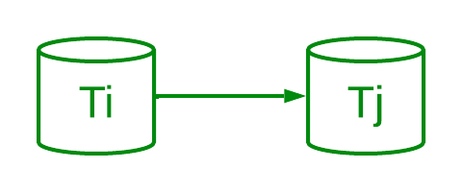Precedence Graph

It can be described as a Graph G(V, E) with vertices V = "V1, V2, V3,..., Vn" and directed edges E = "E1, E2, E3,..., En". One of the two operations—READ or WRITE—performed by a certain transaction is contained in the collection of edges. Where Ti -> Tj, means Transaction-Ti is either performing read or write before the transaction-Tj.

Types of Serializability

There are two ways to check whether any non-serial schedule is serializable.

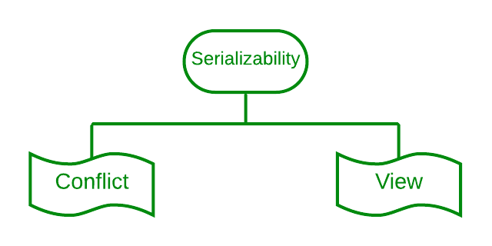Types of Serializability - Conflict & View

1. Conflict serializability

[Conflict serializability](https://www.geeksforgeeks.org/conflict-serializability-in-dbms/) refers to a subset of serializability that focuses on maintaining the consistency of a database while ensuring that identical data items are executed in an order. In a DBMS each transaction has a value and all the transactions, in the database rely on this uniqueness. This uniqueness ensures that no two operations with the conflict value can occur simultaneously.

For example lets consider an order table and a customer table as two instances. Each order is associated with one customer even though a single client may place orders. However there are restrictions for achieving conflict serializability in the database. Here are a few of them.

1. Different transactions should be used for the two procedures.
2. The identical data item should be present in both transactions.
3. Between the two operations, there should be at least one write operation.

Example

Three transactions—t1, t2, and t3—are active on a schedule "S" at once. Let's create a graph of precedence.

| Transaction - 1 (t1) | Transaction - 2 (t2) | Transaction - 3 (t3) |
| --- | --- | --- |
| R(a) |  |  |
|  | R(b) |  |
|  |  | R(b) |
|  | W(b) |  |
| W(a) |  |  |
|  |  | W(a) |
|  | R(a) |  |
|  | W(a) |  |

It is a conflict serializable schedule as well as a serial schedule because the graph (a DAG) has no loops. We can also determine the order of transactions because it is a serial schedule.

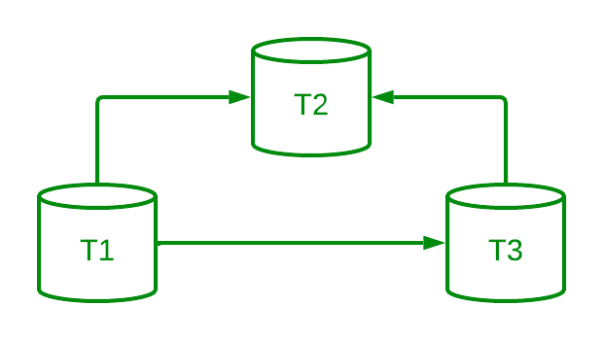DAG of transactions

As there is no incoming edge on Transaction 1, Transaction 1 will be executed first. T3 will run second because it only depends on T1. Due to its dependence on both T1 and T3, t2 will finally be executed.

Therefore, the serial schedule's equivalent order is: t1 --> t3 --> t2

Note: A schedule is unquestionably consistent if it is conflicting serializable. A non-conflicting serializable schedule, on the other hand, might or might not be serial. We employ the idea of View Serializability to further examine its serial behavior.

Mention various types of records. Describe how they are organized inside a file?

**Types of Records in a Database**

In a database system, records represent the individual data entries stored in a table or file. The organization of records depends on the structure of the file and the types of records stored. Below are various types of records:

**1. Fixed-Length Records**

* **Description**: In fixed-length records, each record occupies a fixed amount of space in the file, regardless of the actual data stored. This type of record is efficient because the length of each record is predetermined, making it easy to access and manage.
* **Example**:
  + A record storing an employee's information, such as ID (4 bytes), Name (20 bytes), and Age (2 bytes). The total length of the record is fixed at 26 bytes.

**2. Variable-Length Records**

* **Description**: In variable-length records, the length of each record varies depending on the actual data stored. The size of a record is not fixed, so there must be a way to indicate the end of the record or store its size.
* **Example**:
  + A record with fields such as Name (string) and Address (string), where the name and address length can vary for each record.

**3. Packed Records**

* **Description**: Packed records are a form of variable-length records, but the data is stored in a compact, binary format, often without extra padding. These records are packed tightly together, and padding is minimized to save space.
* **Example**:
  + A packed record for an employee might store the Employee ID as a 4-byte integer, the age as a 1-byte field, and the name as a compressed string.

**4. Hierarchical Records**

* **Description**: Hierarchical records are organized in a tree-like structure, where each record is linked to a parent or child record. These records represent a hierarchical relationship, commonly used in tree or graph-based data models.
* **Example**:
  + A record representing an employee, with sub-records for their department, manager, and team members.

5. Indexed Records

* Description: Indexed records are records that are accessed via an index rather than by direct access to the file. An index is typically a separate structure that points to the physical location of each record in the file, making it quicker to locate specific records.
* Example:
  + A record for a product might include an index key (e.g., Product ID) that helps quickly locate the product record in the database**.**

Sequential Organization

* Description: In sequential organization, records are stored one after another in the order they are created. Accessing records is done sequentially, which means records can only be read from the beginning to the end unless additional indexing is used.
* Example:
  + A list of records representing customers, ordered by their Customer ID.
* Characteristics:
  + Simple to implement.
  + Inefficient for search and retrieval operations that require accessing records at random.

2. Hashed Organization

* Description: Hashed organization uses a hash function to compute the storage location of records. Each record is assigned to a specific "bucket" or "slot" based on the hash value of a key attribute (e.g., employee ID). This allows for efficient and direct access to records.
* Example:
  + A file where the hash of the employee ID determines where each employee's record is stored.
* Characteristics:
  + Very efficient for equality searches (e.g., finding a specific record).
  + Less efficient for range queries, as there is no ordering.

3. B-Tree or B+ Tree Organization

* Description: In B-Tree or B+ Tree organization, records are stored in a balanced tree structure. These trees allow for efficient searching, insertion, and deletion operations while maintaining an ordered structure of records.
* Example:
  + A product catalog indexed by product ID, where the tree structure allows for quick searching and sorting.
* Characteristics:
  + Efficient for both searching and range queries.
  + Requires complex data structures but ensures balanced performance for large datasets.

4. Clustered Organization

* Description: In clustered organization, records that are related to each other are stored physically close together on disk. This improves performance by minimizing disk seek times when retrieving related records.
* Example:
  + Customer records and their associated order records are stored together in a cluster, making it faster to retrieve all information related to a customer.
* Characteristics:
  + Improves performance for retrieving related data.
  + May cause inefficiencies when records are not grouped logically.

**explain in detail about ISAM?**

Indexed sequential access method (ISAM)

ISAM method is an advanced sequential file organization. In this method, records are stored in the file using the primary key. An index value is generated for each primary key and mapped with the record. This index contains the address of the record in the file.

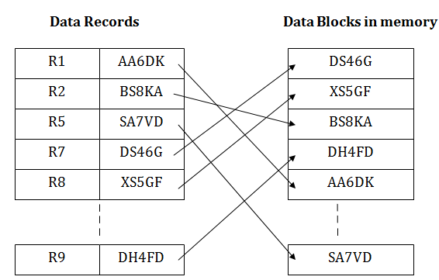

If any record has to be retrieved based on its index value, then the address of the data block is fetched and the record is retrieved from the memory.

Pros of ISAM:

* In this method, each record has the address of its data block, searching a record in a huge database is quick and easy.
* This method supports range retrieval and partial retrieval of records. Since the index is based on the primary key values, we can retrieve the data for the given range of value. In the same way, the partial value can also be easily searched, i.e., the student name starting with 'JA' can be easily searched.

Cons of ISAM

* This method requires extra space in the disk to store the index value.
* When the new records are inserted, then these files have to be reconstructed to maintain the sequence.
* When the record is deleted, then the space used by it needs to be released. Otherwise, the performance of the database will slow down.

**Write about indexed sequential files with advantages and disadvantages.**

An **indexed sequential file** is a type of file organization in which records are stored in a sequential manner based on a key field, and an index is maintained to allow quick access to any record using its key. The main advantage of this organization is that it combines the benefits of both **sequential access** (for processing records in order) and **direct access** (using an index to quickly locate specific records).

In an indexed sequential file, there are two main components:

1. **Data File**: This is where the actual records are stored sequentially. The records are ordered based on a key field (e.g., employee ID, product code).
2. **Index File**: This is a separate file that contains pointers to the records in the data file. The index file maps key values to the location of the corresponding record in the data file.

**Working of Indexed Sequential File**

1. **Sequential Search**:
   * The records in the data file are stored sequentially based on a key field, so the records can be processed in order. To find a specific record, a sequential search might be performed.
2. **Indexing**:
   * An index is maintained for faster searching. The index file contains key-value pairs, where the key is the record’s key field, and the value is a pointer to the corresponding record in the data file. The index allows for quicker lookup, reducing the need for a full sequential search.
3. **Update Operations**:
   * When new records are added, they are inserted into the data file in the correct order based on the key field. The index is updated accordingly to reflect the new record locations.
4. **Accessing a Record**:
   * To access a record, the system first looks up the key in the index file to find the pointer to the record in the data file, which is then accessed directly. This combination of direct access (via the index) and sequential access (within the data file) improves both search and insertion performance.

**Advantages of Indexed Sequential Files**

1. **Faster Access to Records**:
   * The index provides a faster way to locate records compared to a simple sequential search. Once the correct index entry is found, the record can be accessed directly, reducing the time needed for searching.
2. **Efficient for Range Queries**:
   * Since records are stored sequentially, range queries (e.g., retrieving all records with a key in a certain range) can be processed efficiently, especially if the index allows direct access to the starting point of the range.
3. **Efficient for Insertion and Deletion**:
   * Inserting new records or deleting records can be done efficiently while maintaining the sequential order. The index is updated automatically when records are added or deleted, ensuring fast subsequent access.
4. **Combines Sequential and Direct Access**:
   * Indexed sequential files combine the best of both worlds: sequential access for processing large numbers of records in order and indexed access for fast lookup of individual records. This makes it a good choice for applications requiring both types of operations.

**Disadvantages of Indexed Sequential Files**

1. **Complexity**:
   * The organization and maintenance of indexed sequential files are more complex than simple sequential files. Both the data file and index file need to be maintained, which requires extra overhead in terms of space and processing.
2. **Index File Storage**:
   * The index file takes up additional storage space, which can be significant, especially when there are a large number of records. In some cases, the index file can become quite large compared to the actual data file.
3. **Performance Degradation with Large Files**:
   * As the number of records grows, maintaining the index and ensuring efficient access can become more difficult. The performance of searches and updates can degrade if the index file is not properly optimized or if the records are frequently modified.
4. **Need for Periodic Reorganization**:
   * If records are added or deleted frequently, the file may become fragmented. In such cases, the file may need to be reorganized periodically to maintain efficient access, which can be time-consuming and resource-intensive.

**Define index. Explain it’s types.**

Indexing in DBMS

* Indexing is used to optimize the performance of a database by minimizing the number of disk accesses required when a query is processed.
* The index is a type of data structure. It is used to locate and access the data in a database table quickly.

Index structure:

Indexes can be created using some database columns.

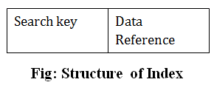

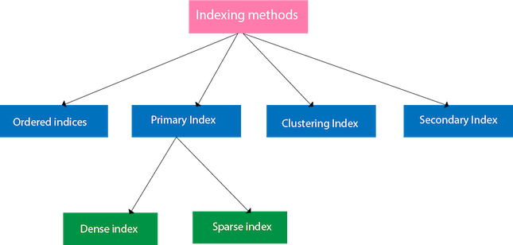

Ordered indices

The indices are usually sorted to make searching faster. The indices which are sorted are known as ordered indices.

**Example**: Suppose we have an employee table with thousands of record and each of which is 10 bytes long. If their IDs start with 1, 2, 3....and so on and we have to search student with ID-543.

* In the case of a database with no index, we have to search the disk block from starting till it reaches 543. The DBMS will read the record after reading 543*10=5430 bytes.
* In the case of an index, we will search using indexes and the DBMS will read the record after reading 542*2= 1084 bytes which are very less compared to the previous case.

Primary Index

* If the index is created on the basis of the primary key of the table, then it is known as primary indexing. These primary keys are unique to each record and contain 1:1 relation between the records.
* As primary keys are stored in sorted order, the performance of the searching operation is quite efficient.
* The primary index can be classified into two types: Dense index and Sparse index.

Dense index

* The dense index contains an index record for every search key value in the data file. It makes searching faster.
* In this, the number of records in the index table is same as the number of records in the main table.
* It needs more space to store index record itself. The index records have the search key and a pointer to the actual record on the disk.

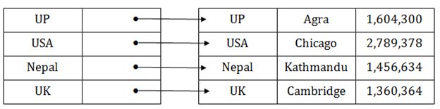

Sparse index

* In the data file, index record appears only for a few items. Each item points to a block.
* In this, instead of pointing to each record in the main table, the index points to the records in the main table in a gap.

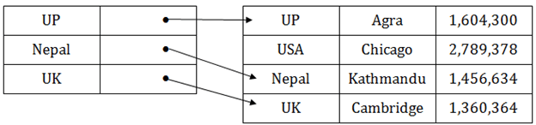

Clustering Index

* A clustered index can be defined as an ordered data file. Sometimes the index is created on non-primary key columns which may not be unique for each record.
* In this case, to identify the record faster, we will group two or more columns to get the unique value and create index out of them. This method is called a clustering index.
* The records which have similar characteristics are grouped, and indexes are created for these group.

**Example**: suppose a company contains several employees in each department. Suppose we use a clustering index, where all employees which belong to the same Dept_ID are considered within a single cluster, and index pointers point to the cluster as a whole. Here Dept_Id is a non-unique key.

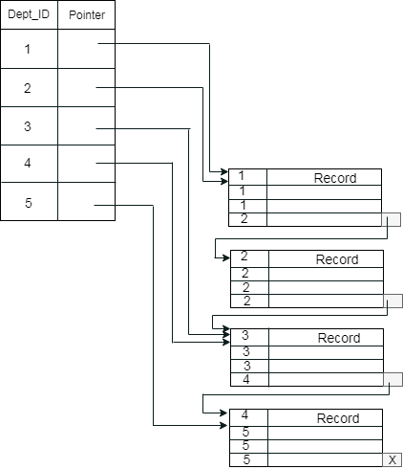

The previous schema is little confusing because one disk block is shared by records which belong to the different cluster. If we use separate disk block for separate clusters, then it is called better technique.

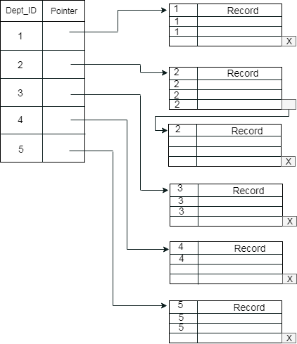

Secondary Index

In the sparse indexing, as the size of the table grows, the size of mapping also grows. These mappings are usually kept in the primary memory so that address fetch should be faster. Then the secondary memory searches the actual data based on the address got from mapping. If the mapping size grows then fetching the address itself becomes slower. In this case, the sparse index will not be efficient. To overcome this problem, secondary indexing is introduced.

In secondary indexing, to reduce the size of mapping, another level of indexing is introduced. In this method, the huge range for the columns is selected initially so that the mapping size of the first level becomes small. Then each range is further divided into smaller ranges. The mapping of the first level is stored in the primary memory, so that address fetch is faster. The mapping of the second level and actual data are stored in the secondary memory (hard disk).

What is an index? Explain its role in improving database access. What is an index? Explain its role in improving database access. What is an index? Explain its role in improving database access. What is an index? Explain its role in improving database access

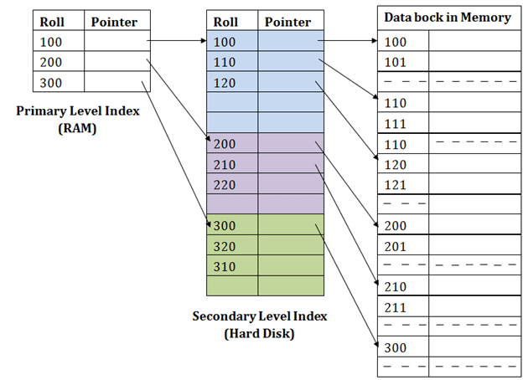

**What is an index? Explain its role in improving database access.**

**. Faster Data Retrieval**

* Without an index, the database would need to search through all rows of a table to find the data (called a **full table scan**), which is slow.
* With an index, the system can quickly locate the position of a record, making data retrieval faster.

**Example**: Searching for a specific **Employee ID** in a table is faster with an index because it directly points to that record, rather than scanning all employees.

**2. Faster Query Execution**

* Indexes speed up queries by providing quick access to data based on specific conditions (like searching by a name or ID).
* For example, **SELECT** queries on indexed columns can be executed much faster.

**Example**: Searching for employees with a specific **Department** ID is faster if there is an index on the **Department ID**.

**3. Efficient Sorting**

* When you want to sort data (using the **ORDER BY** clause), an index on the column being sorted can speed up this operation.
* Instead of sorting the data after retrieval, the system can use the index to directly access sorted data.

**Example**: Sorting employees by **Salary** is quicker if there is an index on the **Salary** column.

**4. Faster Join Operations**

* Indexes help speed up **join operations** between two tables by quickly matching keys (like **Employee ID** or **Department ID**).
* Without an index, joining large tables requires checking each row in both tables, which takes time.

**Example**: Joining an **Employees** table with a **Departments** table on **Department ID** is faster if both tables have indexes on the **Department ID** column.

**5. Support for Range Queries**

* If you're querying data based on a range (like values between two numbers), an index can help quickly find the range's starting and ending points.

**Example**: A query that selects employees with **Salaries between 50,000 and 60,000** can be processed faster with an index on the **Salary** column.

**6. Maintaining Data Integrity**

* Indexes can also be used to enforce **uniqueness** (no duplicates allowed) in a column, such as a **primary key** or **unique key**.

**Example**: The **Employee ID** column can be indexed to ensure no two employees have the same ID, maintaining data integrity.

**Explain about storage structure.**

**Storage Structure in DBMS (Simple Explanation)**

The **storage structure** in a Database Management System (DBMS) refers to the way data is physically stored on the storage media (like hard disks or SSDs). The purpose of a storage structure is to organize and manage how data is stored, retrieved, and updated efficiently.

**Key Components of Storage Structure:**

1. **Data Storage (Tables and Records):**
   * Data is stored in **tables** (rows and columns). Each row represents a record, and each column represents an attribute.
   * Tables are divided into **pages** (small units), and records are stored inside these pages.
2. **Indexing:**
   * **Indexes** are used to speed up data retrieval. An index is like a book's index, pointing to the location of specific data, making it faster to find records in a table.
3. **Buffer/Cache:**
   * A **buffer pool** is used to store frequently accessed data pages in **main memory** (RAM), speeding up data access and reducing disk I/O operations.
4. **Transaction Logs:**
   * **Logs** keep a record of changes (insert, update, delete) made to the database. This helps in recovering data in case of system failures.
5. **File Organization:**
   * **Heap files** store data without a specific order, while **sorted files** store data in a sorted sequence for faster queries.

**Types of Storage Structures:**

1. **Heap Storage:**
   * Data is stored in no particular order. New data is added at the end of the file. It’s simple but slow for searching.
   * **Example**: Suitable for small or unordered data.
2. **Indexed Storage:**
   * Data is stored with an **index** for faster search and retrieval.
   * **Example**: Faster searching, suitable for large datasets.
3. **Clustered Storage:**
   * Related data is stored together to minimize disk access.
   * **Example**: Used in join operations where data from different tables is accessed together.

**Role of Storage Structures in DBMS:**

1. **Improves Data Access:** Organized storage reduces the time to find and retrieve data.
2. **Reduces Disk I/O:** Using indexes and buffers helps minimize expensive disk reads.
3. **Enhances Performance:** Proper organization of data leads to faster queries and better response times.
4. **Data Integrity and Recovery:** Transaction logs ensure that changes are tracked and the system can recover data if something goes wrong.

**Discuss about data on External storage.**

Data on External Storage in DBMS (Simple Explanation)

In a Database Management System (DBMS), external storage is used to store large amounts of data on devices like hard drives, SSDs, or magnetic tapes. Since the main memory (RAM) is limited, external storage ensures that all data is stored safely and can be accessed whenever needed.

Why Use External Storage?

1. Large Data Capacity:
   * External storage can hold much more data than main memory.
   * Databases often have large tables and records that need extra space.
2. Permanent Storage:
   * Data stays safe even if the system shuts down (non-volatile).
3. Cost-Effective:
   * External storage is cheaper than RAM for storing large amounts of data.
4. Reliable for Backups:
   * External storage devices like tapes are used to store backups.

Types of External Storage:

1. Hard Drives (HDD):
   * Commonly used for database storage.
   * Stores data on spinning magnetic disks.
2. Solid State Drives (SSD):
   * Faster than HDDs because they have no moving parts.
   * Used for better performance in modern databases.
3. Magnetic Tapes:
   * Used for backups and archives.
   * Slower because data is read sequentially.

How Data is Stored on External Storage?

1. Blocks or Pages:
   * Data is divided into small units called blocks (4KB or 8KB in size).
   * These blocks are moved between external storage and memory when needed.
2. Files:
   * Data like tables, indexes, and logs are stored in files on the storage device.
3. Buffering:
   * Frequently used data is temporarily stored in memory (buffer) to avoid repeated access to external storage.

Challenges of External Storage:

1. Slower Access:
   * Accessing data from external storage takes more time than accessing it from memory.
2. Disk Failures:
   * Data can be lost if the storage device fails.
3. Fragmentation:
   * Over time, data may get scattered, slowing down access.

Optimizing External Storage Use:

1. Indexing:
   * Helps the DBMS quickly locate data on the disk.
2. Buffering:
   * Keeps frequently used data in memory for faster access.
3. Clustering:
   * Stores related data together to minimize disk reads.

Conclusion:

External storage is essential for storing large amounts of data in a DBMS. Though it is slower than memory, techniques like indexing and buffering help improve performance. External storage ensures databases can handle large datasets and store data safely over time.

**What is the difference between Sequential File Organization and Heap File Organization? Explain.**

